SaaS Customer Churn Prediction and Retention Strategy
A Data Analytics & Machine Learning Project
Submitted By:
Name: HARSH VERMA
Course: (BCA)
Semester: (3rd)
University / Company: (CCSU/)
This project is designed to meet academic, corporate, and industry-level standards.

Executive Summary
Customer churn is a major challenge for SaaS organizations as it directly impacts recurring revenue and growth. This project presents an end-to-end churn analytics solution combining business metrics, data visualization, and machine learning techniques. Using Python and SQL, customer behavior is analyzed to identify churn risks, predict future churn, and propose actionable retention strategies. The project is suitable for academic evaluation, corporate analytics teams, and real-world SaaS applications.

1. Introduction
SaaS businesses operate on subscription-based revenue models where customer retention is critical. Even small increases in churn can significantly reduce profitability. This project demonstrates how data-driven churn prediction enables organizations to take proactive retention actions.

2. Business Problem Statement
High customer churn leads to revenue loss, increased acquisition costs, and unstable growth. Organizations need predictive insights to identify at-risk customers before churn occurs.

3. Objectives of the Project
• To understand customer churn behavior
• To calculate key SaaS metrics
• To predict customer churn using machine learning
• To design customer retention strategies
• To improve business decision-making using data

4. Scope & Industry Relevance
• Applicable to SaaS, FinTech, EdTech, HealthTech, and Subscription Platforms
• Useful for marketing, sales, product, and customer success teams
• Scalable for enterprise-level churn monitoring

5. Key Metrics Used (Simplified)
Churn Rate = (Lost Customers / Total Customers) × 100
2. Revenue Churn Rate (MRR Churn)
MRR Churn = (Lost MRR / Total MRR) × 100
3. Customer Retention Rate
Retention1. Customer Churn Rate
Rate = ((End Customers − New Customers) / Start Customers) × 100
4. Customer Lifetime Value (CLTV)
CLTV = ARPU / Churn Rate
5. Customer Acquisition Cost (CAC)
CAC = Total Marketing Cost / New Customers
6. Monthly Recurring Revenue (MRR)
MRR = Customers × Monthly Plan Price
7. User Engagement Metrics
Login frequency, Feature usage, Session duration
8. NPS & CSAT
NPS: Customer loyalty
CSAT: Customer satisfaction

6. Tools & Technologies
- Python (Pandas, NumPy, Scikit-learn)
- SQL
- Matplotlib
- Jupyter Notebook
- Excel/CSV datasets

7. Dataset Description
Customer ID
Subscription plan
Monthly charges
Tenure
Login frequency
Support tickets
Churn status

8. Methodology
- Data collection
- Data cleaning
- Exploratory Data Analysis (EDA)
- Feature engineering
- Churn prediction model
- Retention strategy design

9. Machine Learning Approach
Logistic Regression is used as a baseline churn prediction model due to its interpretability. The model identifies customers with a high probability of churn based on engagement and support behavior.

10. Python Notes
import pandas as pd
df = pd.read_csv('saas_data.csv')
churn_rate = (df[df['churn']==1].shape[0] / df.shape[0]) * 100
mrr = df['monthly_revenue'].sum()
arpu = df['monthly_revenue'].mean()
cltv = arpu / churn_rate
from sklearn.model_selection import train_test_split
from sklearn.linear_model import LogisticRegression
X = df[['login_frequency','support_tickets','tenure']]
y = df['churn']
X_train, X_test, y_train, y_test = train_test_split(X, y)
model = LogisticRegression()
model.fit(X_train, y_train)

11. Business Insights
• Low user engagement strongly correlates with churn
• Customers with frequent support tickets show higher dissatisfaction
• Long-tenure customers have lower churn probability
model.fit(X_train, y_train)

11. SQL Notes
SELECT COUNT(*) FROM customers;
SELECT COUNT(*) FROM customers WHERE churn = 1;
SELECT SUM(monthly_revenue) FROM customers;
SELECT * FROM customers WHERE login_frequency < 5 AND churn = 0;

12. Churn Prediction Results
• Customers with low engagement are more likely to churn
• High support tickets indicate dissatisfaction
• Long-tenure customers churn less

13. Data Visualization & Insights

Customer Churn Distribution
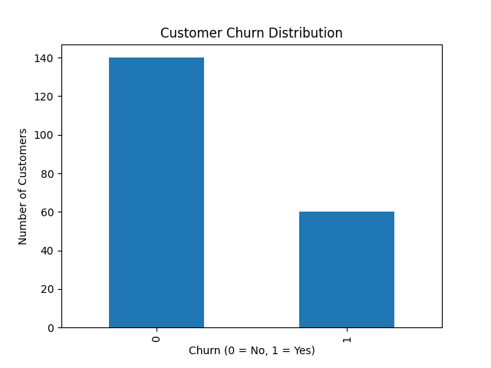
Provides a high-level view of retained vs churned customers.

MRR Trend Analysis
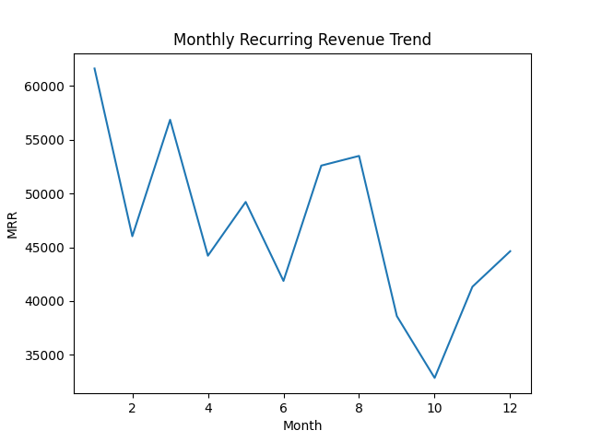
Highlights revenue stability and potential revenue churn.

User Engagement vs Churn
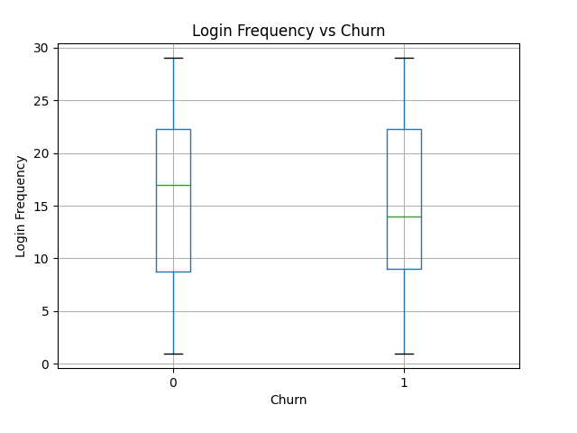
Demonstrates the impact of engagement on churn probability.

Customer Lifetime Value Distribution
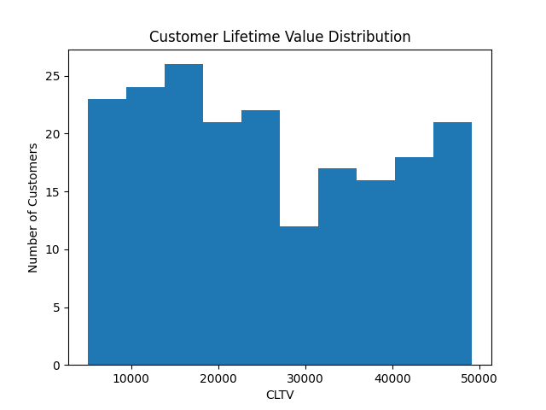
Identifies high-value customers critical for business growth.

Support Tickets vs Churn
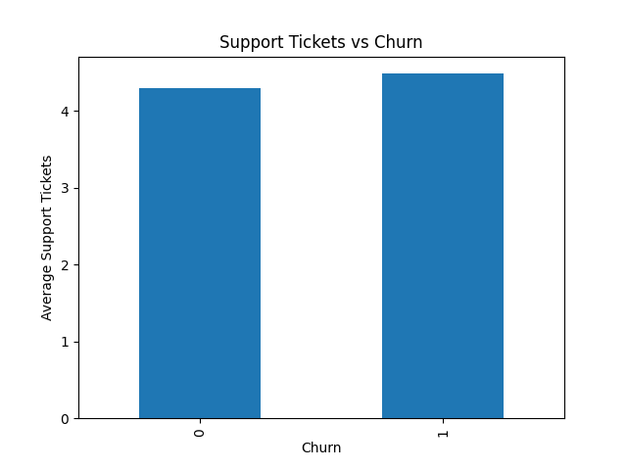
Links customer dissatisfaction with increased churn risk.

14. Retention Strategy Framework
• Personalized onboarding and feature recommendations
• Proactive engagement for low-usage customers
• Priority support for high-value customers
• Pricing optimization and long-term subscription incentives
• Continuous feedback through NPS and CSAT surveys

15. Business Impact
Implementing the proposed churn prediction framework can reduce churn, increase customer lifetime value, stabilize monthly recurring revenue, and improve customer satisfaction—making the solution valuable for real-world enterprise environments.

16. Conclusion & Future Scope
This project demonstrates a scalable and industry-ready churn analytics solution. Future enhancements include real-time churn monitoring, advanced ML models, AI-driven recommendations, and NLP-based sentiment analysis for customer feedback.

